LYNNFIELD WATER DISTRICT
11/23/20:
Lynnfield Peabody Weekly
Lynn Item
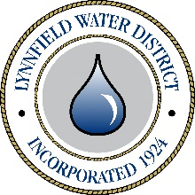
Board of Water Commissioners
Public hearing
Tax Rate Classification
The Board of Water Commissioners of the Lynnfield Water District will hold a public hearing on Thursday, December 3, 2020 at 7:00 p.m. In accordance with Governor Baker’s Executive Order of March 12, 2020, the hearing will be held remotely.
The hearing concerns the allocation of the Lynnfield Water District tax levy among the five property classes, as defined in Section 2A of Massachusetts General Law, Chapter 59, for the fiscal year 2020 beginning July 1, 2020. Residents, as well as interested persons, are invited to attend and participate in the hearing via GoToMeeting using the link below.
Ruth E. McMahon
Chairman
Thu, Dec 3, 2020 7:00 PM (EST)
From your computer, tablet, or smartphone.
https://global.gotomeeting.com/join/858083525
Or, you can also dial in using your phone.
United States: +1 (571) 317-3122
Access Code: 858-083-525

